Create Route 53 Public Hosted Zone
Topic: Hosted zone configuration for the domain hash-lab.example
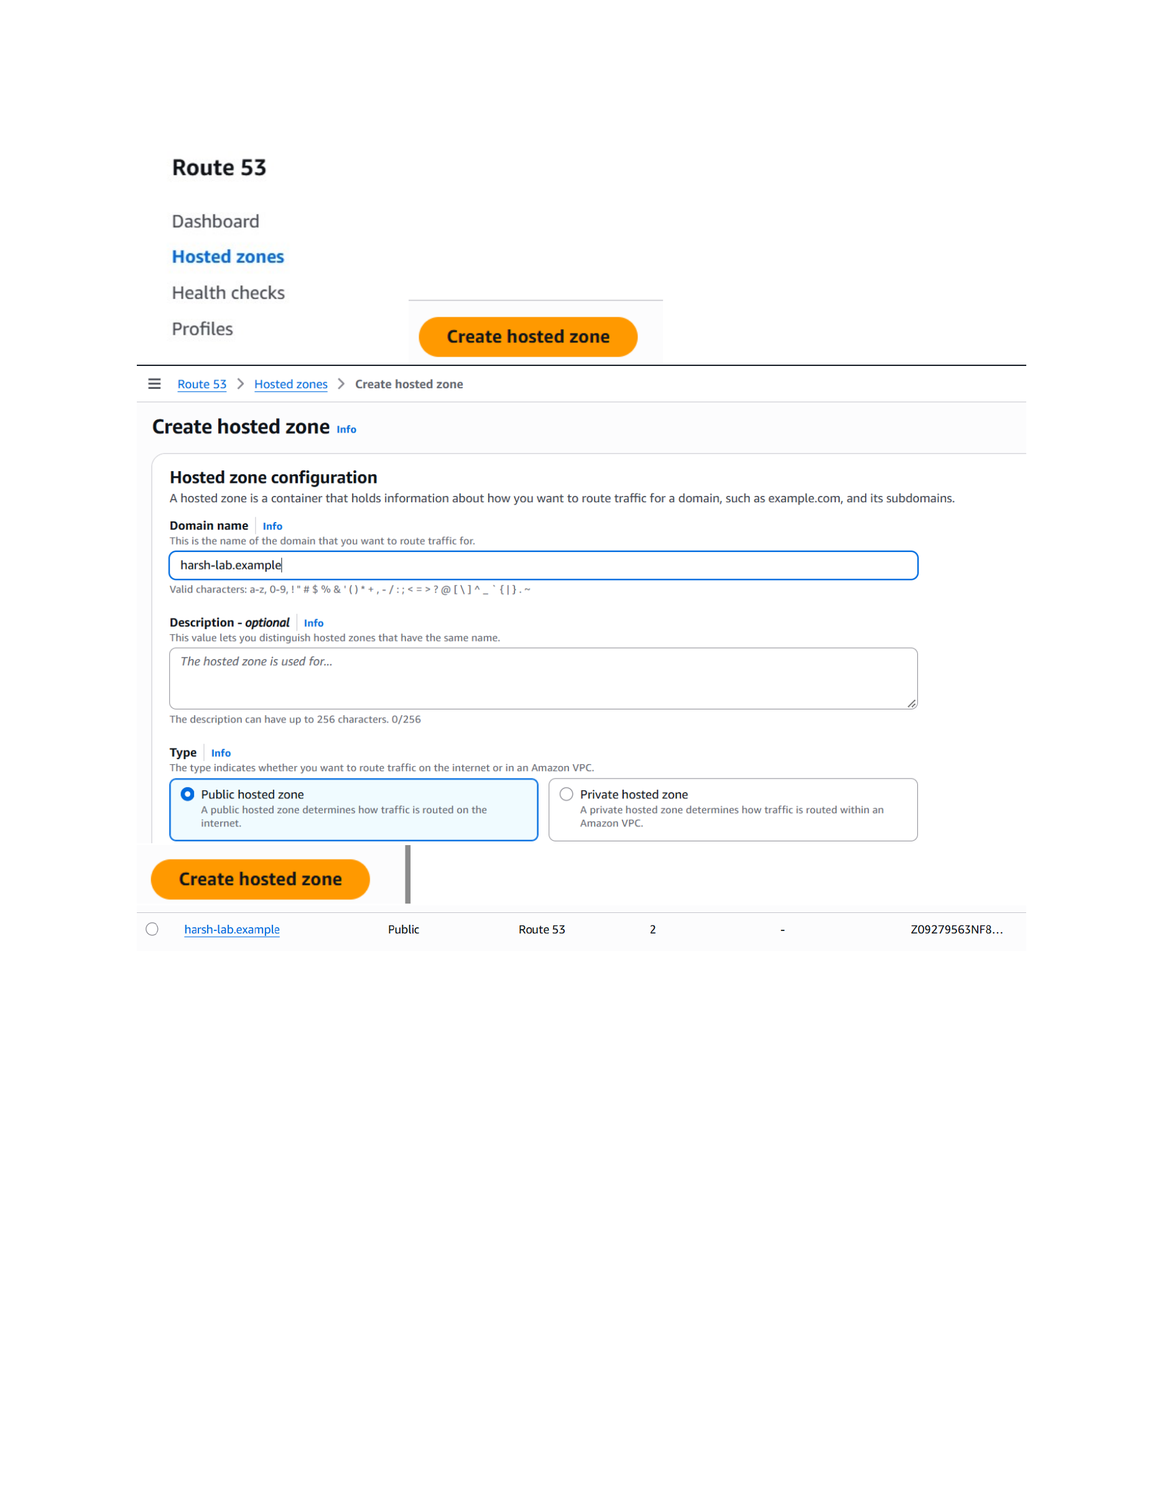
Action: Route 53 Hosted zones se create hosted zone screen open karke domain name “harsh-lab.example” enter kiya gaya. Public hosted zone select karke hosted zone create ki gayi, jiske baad zone list mein domain visible ho gaya.

Create an A Record for the EC2 Server
Topic: DNS record creation using the EC2 public IPv4 address
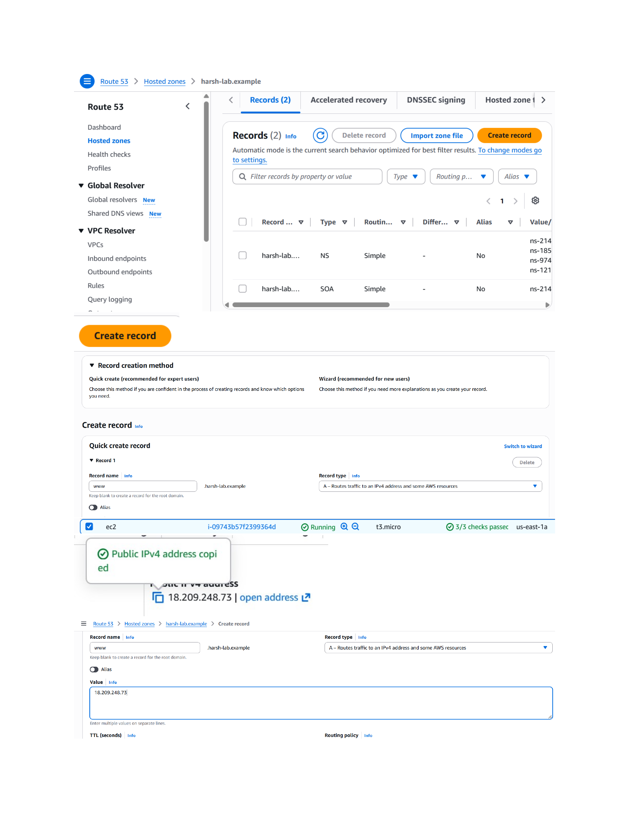
Action: Hosted zone ke Records section mein Create record choose kiya gaya. Record name “www” rakha gaya, record type A select kiya gaya, aur EC2 ka public IPv4 address 18.209.248.73 value ke roop mein enter kiya gaya.

Verify the DNS Record and Name Resolution
Topic: Route 53 record confirmation and nslookup verification
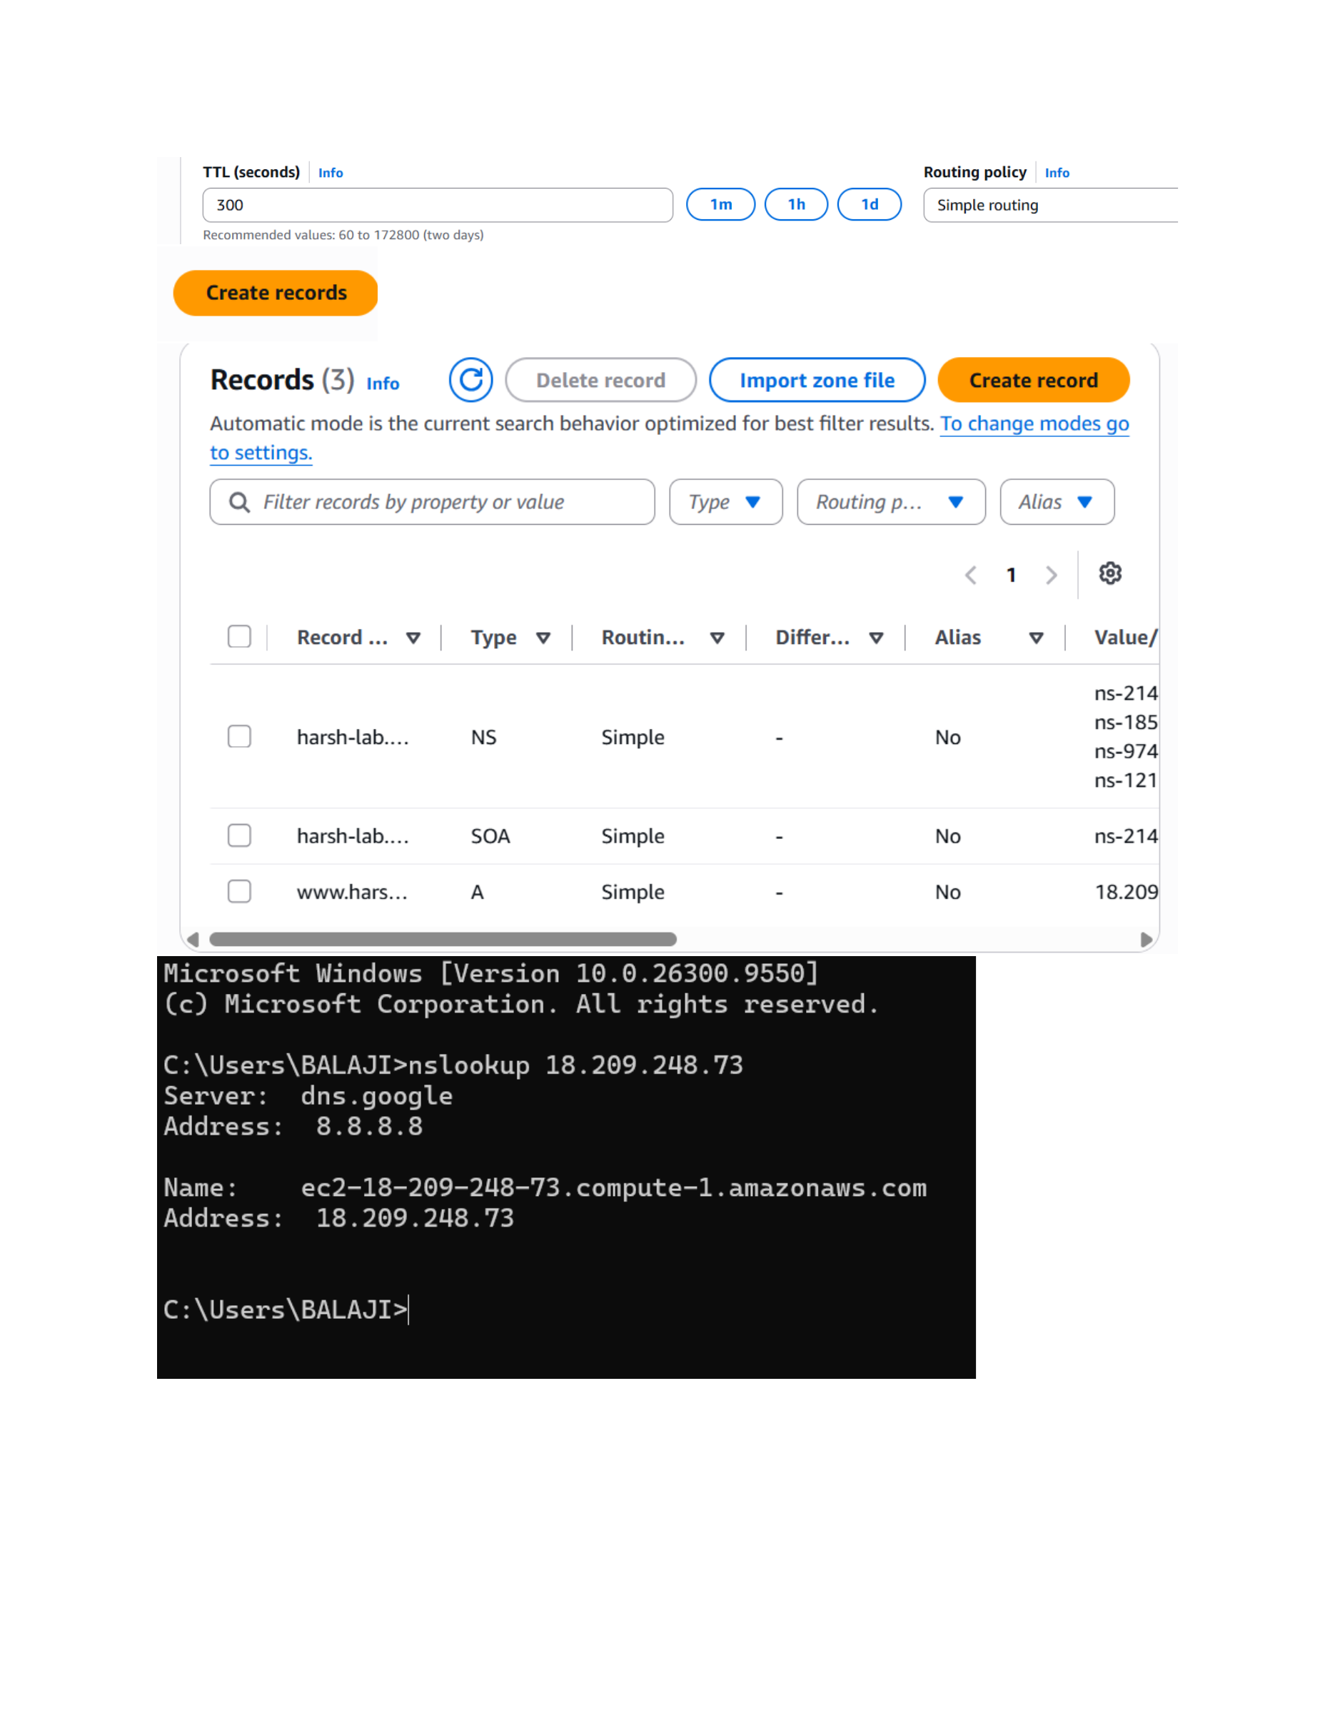
Action: Create records ke baad Records list mein www ka A record visible hua. Windows Command Prompt mein “nslookup 18.209.248.73” run karke DNS response verify kiya gaya, jisme EC2 hostname aur address 18.209.248.73 return hua.

